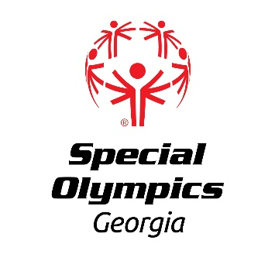

2025 STATE INVITATIONAL SCHEDULE

The following is a schedule of confirmed State Invitationals. Additional Invitationals will be added to this schedule and updates will be available.

**SPORT DATE LOCATION** **_________**

Athletics 4/25/2025 Greater Atlanta Christian School, Norcross, GA

Pickleball 4/26/2025 Dekalb Tennis Center, Decatur, GA

Golf 5/5/2025 UGA Golf Course, Athens, GA

Kayaking 8/2/2025 Lake Glade Marina, Acworth, GA

Golf 9/12/2025 Lake Arrowhead, Waleska, GA

Softball – Battle of the Bats 9/13/2025 Central Park, Cumming, GA

Kayaking 9/27/2025 Lake Tobesofkee, Macon, GA

Softball/Bocce 10/4/2025 Boundary Waters Park, Douglasville, GA

Bowling 11/7/2025 Stars and Strikes, Columbus, GA

Bowling 11/15/2025 Southern Lanes Bowling Alley, Douglasville GA

Basketball 12/20/2025 Boundary Waters Park, Douglasville, GA

DanceSport TBD (reschedule) Nixon Centre Performing Arts, Newnan, GA

For any questions, please contact the assigned SOGA contact Liz Smith, [liz.smith@specialolympicsga.org](mailto:liz.smith@specialolympicsga.org)